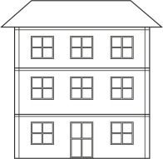
Application Form for KBS House

Send the completed form by email to: kym-kbs@adst.keio.ac.jp
Deadline: Friday, November 10, 2017

*You must read the KBS House Information and understand the rules before applying.
Check-in date and time: January 9, 2018, after the mandatory orientation

I agree to the conditions mentioned in KBS House Information and will abide by the rules and regulations stipulated by Keio University for use of its facilities. I understand and agree that the room assignments will be made by KBS Office, including the room type (single or suite). I further agree that in case the number of applicants to KBS House exceeds the capacity, tenants will be decided by random drawing.

Room Type | Fee | Number of Rooms
Single Room | 60,000 yen/month (2,000 yen/day) | 13
Suite Room (for 2) | 50,000 yen/month (1,700 yen/day) | 1

Check-in date: January 9, 2018 Check-out date: March 23, 2018

Name: Home Institution:

Date: Signature:

